|  |  |
| --- | --- |
| Description: cee_3line_b_4c_pc_[Converted] | [Description: https://confluence.cornell.edu/download/attachments/10420888/aguaclara_new_logo.jpg](file:///C:\Documents%20and%20Settings\mas352\Desktop\Final%20Designs\DesignSpecs\aguaclara.cee.cornell.edu) |

PRELIMINARY DESIGN FORUI.CityUI.State, UI.Country

UI.Name

UI.Organization

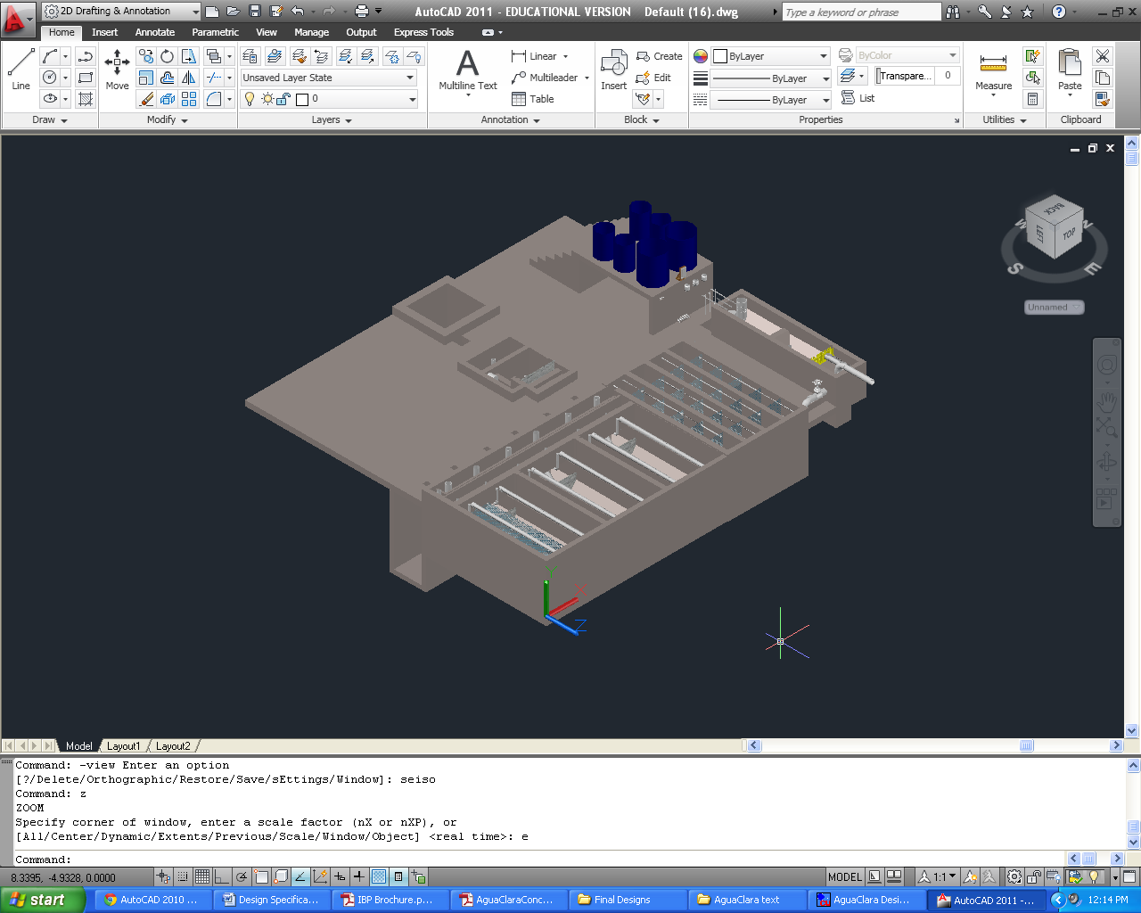

June 5, 2014 at 2:38:25 PM

Copyright © 2010 Cornell University

Table of Contents

[Disclaimer 4](#_Toc326145215)

[Permission and Licensing Information 4](#_Toc326145216)

[Introduction to AguaClara 5](#_Toc326145217)

[The sustainable approach 5](#_Toc326145218)

[The treatment process 6](#_Toc326145219)

[The AguaClara Design Tool 7](#_Toc326145220)

[Design Parameters 8](#_Toc326145221)

[Plant Components 9](#_Toc326145222)

[Entrance tank/preliminary sedimentation 9](#_Toc326145223)

[Linear flow orifice meter (LFOM) 11](#_Toc326145224)

[Chemical dose controller (CDC) 12](#_Toc326145225)

[Chemical storage tanks 16](#_Toc326145226)

[Rapid Mix 18](#_Toc326145227)

[Flocculation 19](#_Toc326145228)

[General Flocculator Design 20](#_Toc326145229)

[Inlet Channel 20](#_Toc326145230)

[Sedimentation Tanks 21](#_Toc326145231)

[Assigning dimensions to the sedimentation tank 22](#_Toc326145232)

[Inlet Manifolds 23](#_Toc326145233)

[Sludge drain 25](#_Toc326145234)

[Tolvas 25](#_Toc326145235)

[Plate settlers 25](#_Toc326145236)

[Launders 26](#_Toc326145237)

[Canal de salida 27](#_Toc326145238)

[Chlorine Disinfection 27](#_Toc326145239)

[Manejo de lodos 29](#_Toc326145240)

[Stacked Rapid Sand Filtration: SRSF 29](#_Toc326145241)

[Materials List 32](#_Toc326145242)

[Entrance Tank 32](#_Toc326145243)

[Flocculation Tank 32](#_Toc326145244)

[Sedimentation Tank 32](#_Toc326145245)

[SRSF 32](#_Toc326145246)

|  |  |
| --- | --- |
| Description: cee_3line_b_4c_pc_[Converted] | Description: https://confluence.cornell.edu/download/attachments/10420888/aguaclara_new_logo.jpg  <http://aguaclara.cee.cornell.edu/>  Dr. Monroe Weber-Shirk, Director |

This preliminary design was requested by UI.Name.FirstUI.Name.Last on behalf of UI.Organization. The design was created on June 5, 2014 at 2:38:25 PM by the AguaClara Design Server at Cornell University. The design is for UI.CityUI.State, UI.Country and has a design flow rate of Q.Plant. The design was created with MathCAD code version SVN.Version.

This design is the result of over 20,000 hours of undergraduate, graduate, and faculty labor. The design incorporates advanced fluid dynamics analysis to ensure easy backwash during filtration. The chemical feed system is based on a series of inventions by the AguaClara team that make it possible to directly set the desired chemical dose and to maintain that dose automatically even as the flow rate through the plant varies..

The economic value of this design is approximately 10,000 USD. This estimate is based on the amount of time that would be required to create this design if an environmental engineering firm used the AguaClara design algorithms, but not the automated design tool, to create this design. The AguaClara team is committed to continue providing this design service because we want to encourage new implementation partners to explore the use of this technology. We also recognize that high design costs would prevent this technology from being available to small communities. However, we do require funding to maintain our design team and to continue to integrate improvements into our designs. We recommend that implementation partners include a design fee for the AguaClara design service in the project budget. The nominal fee (far below its true value) for use of this design service is 1000 USD per L/s of plant capacity. You are welcome to create multiple designs for each facility that you intend to construct to obtain an optimal plant configuration. This fee, which will guarantee continued technical support from the AguaClara team, can be paid to AguaClara by check or [online to Cornell University](http://sites.google.com/site/cuaguaclara/donate). This fee will likely be between 1% and 2% of the overall project cost for a water treatment plant. Thank you for your support.

##### Donate by Check

Make the check to Cornell University

Write AguaClara in the memo field

Mail to: AguaClara, 220 Hollister Hall, Cornell University, Ithaca, NY 14853

# Disclaimer

This document is a DRAFT. It has not been reviewed for official release. It is included with the design files to show what we plan to deliver in the near future.

This design, including the files accompanying this document, is only a draft and must be reviewed and approved by a licensed engineer prior to construction. If you have questions about this design please contact the AguaClara design team at Cornell University at [CUAguaClara@gmail.com](mailto:CUAguaClara@gmail.com).

### Permission and Licensing Information

Copyright © 2010 Cornell University

Authors: The AguaClara team at Cornell University under the supervision of Dr. Monroe Weber-Shirk

This design was created using the open source engineering services of the AguaClara program at Cornell University. It is subject to the [Creative Commons Attribution-ShareAlike 3.0](http://creativecommons.org/licenses/by-sa/3.0/us/legalcode) United States license. If you alter, transform, or build upon this work, you may distribute the resulting work only under the same, similar or a compatible license.

Permission to use this AguaClara Design Tool along with the subsequent AutoCAD renderings and supporting files for design specifications provided by Cornell based on your input parameters (collectively "WORK") and their associated copyrights without a written agreement is hereby granted. Any water treatment plants built using this WORK shall be designed and supervised by a licensed civil engineer.

IN NO EVENT SHALL CCTEC, CORNELL UNIVERSITY, OR THEIR EMPLOYEES BE LIABLE TO ANY PARTY FOR DIRECT, INDIRECT, SPECIAL, INCIDENTAL, OR CONSEQUENTIAL DAMAGES, INCLUDING LOST PROFITS, ARISING OUT OF THE USE OF WORK AND ITS ASSOCIATED COPYRIGHTS, EVEN IF CCTEC OR CORNELL MAY HAVE BEEN ADVISED OF THE POSSIBILITY OF SUCH DAMAGE.

THE WORK PROVIDED HEREIN IS ON AN "AS IS" BASIS, AND CCTEC, CORNELL, AND THEIR EMPLOYEES HAVE NO OBLIGATION TO PROVIDE MAINTENANCE, SUPPORT, UPDATES, ENHANCEMENTS, OR MODIFICATIONS. CCTEC, CORNELL, AND THEIR EMPLOYEES MAKE NO REPRESENTATIONS AND EXTEND NO WARRANTIES OF ANY KIND, EITHER IMPLIED OR EXPRESSED, INCLUDING, BUT NOT LIMITED TO, THE IMPLIED WARRANTIES OF MERCHANTABILITY OR FITNESS FOR A PARTICULAR PURPOSE, OR THAT THE USE OF WORK AND ITS ASSOCIATED COPYRIGHTS WILL NOT INFRINGE ANY PATENT, TRADEMARK OR OTHER RIGHTS.

Users of WORK shall indemnify, hold harmless and defend Cornell, its officers, employees, agents, and the sponsors of the research that let to WORK against any and all claims, suits, losses, damage, costs, fees, and expenses resulting from or arising out of use of WORK. This indemnification shall include, but not be limited to, any product liability. Users of WORK, at their sole cost and expense, shall sufficiently insure their activities in connection with the WORK and obtain, keep in force, and maintain insurance or an equivalent program of self insurance. Cornell shall notify users of WORK in writing of any claim or suit brought against Cornell in respect of which Cornell intends to invoke the provisions of this paragraph. Users of WORK shall keep Cornell informed on a current basis of its defense of any claims under this paragraph.

# Introduction to AguaClara

## The sustainable approach

AguaClara is a program in Civil and Environmental Engineering at Cornell University thatis improving drinking water quality through innovative research, knowledge transfer, open-source engineering, and replicable designof sustainable municipal water treatment systems.

The team is directed by Monroe Weber-Shirk and has worked in Honduras in partnership with a local NGO, AguaPara el Pueblo, and in India with the Tata Foundation and the NGO Pradan. The AguaClara program received the 2011 Intel Environment Tech Award in recognition of the success of the program in developing sustainable technologies and effective governance models.

Cornell-designed AguaClara municipal water treatment plants are providing nine Honduran towns with populations between 1,500 and 15,000 with safe drinking water from their taps. The AguaClara plants in Honduras produce safe drinking water with turnkey design, construction, operation, training, and transfer costs of $20 to $30 per person served and incremental operating costs of $2-$4 per person per year. The AguaClara technology is uniquely capable of producing high quality drinking water from turbid surface waters without using electricity. The facilities use gravity powered chemical dosing, hydraulic flocculation (to form large aggregates from the contaminants, or flocs), high-rate sedimentation using custom-fabricated plate settlers (to remove the flocs), stacked rapid sand filtration, and disinfection using liquid chlorine (to kill any residual pathogens that escaped the previous treatment steps). The designs rely on materials that are sourced in the community and national supply chains. The municipal water treatment plants are designed to be easy and economical to operate.

In India, AguaClara facilities use chemical dosing systems and low flow stacked rapid sand filters to treat groundwater, again, without using electricity.

Extending safe drinking water coverage to resource poor communities requires multiple engineering innovations and a new approach to implementation and governance. Our robust technologies do not require electricity or external power sources. Our governance model is based on community ownership, community-based democratic governance, and technologies that are specifically designed to be easy to operate and to encourage pride in ownership. We build implementation partner capacity and intend to encourage the formation of a network of implementation partners that will share best practices for implementation and long-term operation of community-based water treatment facilities.

This integrated model of technology development for compatibility with a sustainable governance model has proven extremely successful. All AguaClara facilities are owned and operated by their respective communities and all facilities continue to provide safe drinking water. This is particularly noteworthy in Honduras where most water treatment plants for large cities do not reliably meet drinking water standards. Several towns with AguaClara facilities are experiencing reverse migration from Tegucigalpa due to their superior water.

Democratic community governance through an elected water board has proven to be very effective and the water boards use the water tariffs (that the community has voted to increase) to fund improvements to their water supply infrastructure. Water boards with AguaClara facilities have invested in reforestation of their watershed, upgrades to their distribution system, extensions to their distribution system to add new customers, and ongoing maintenance of the water supply infrastructure. Customer willingness to pay for safe drinking water is significantly higher than their willingness to pay for unsafe rive rwater and the difference is greater than the increased operation and maintenance cost of providing safe drinking water using AguaClara technologies.

Our goal is to disseminate this technology and our learning regarding sustainable governance globally. The AguaClara engineering designs are shared online to facilitate technology dissemination and to reduce design costs. National engineering firms (non-profit, private, or governmental) are trained to build the water treatment facilities using locally available materials and community labor. Our partners work with locally-trusted organizations to develop a governance model that is suited to the natural resources, national governance framework and available social and human capital of a particular community.

We are seeking funding that will support our research and development work to extend therange of community sizes that can be served using the AguaClara technologies. We haveexperience with communities between 1,500 and 15,000 and plan to extend that range inboth directions. We are researching several technologies that have the potential to reduce the construction and operating costs of the water treatment plants and need funding to support that effort. There are significant engineering and governance challenges as we develop approaches to community based water treatment for communities with fewer than1,500 inhabitants. Extending our design capabilities for treatment facilities that can serve larger cities is easier. The engineering and technical challenges will require developing new fabrication methods, testing prototypes for performance, and coding the new designs for dissemination via our online design tool.

We are also interested in testing models for implementation and governance. Our experience suggests that partnerships between the AguaClara team at Cornell, implementation partners, and community governance bodies realize their full potential when there is a high level of trust between the organizations and an ongoing technical assistance circuit rider. The AguaClara technologies are designed to encourage the creation of trust and self-sufficiency by being easy to understand and easy to maintain even in resource poor communities. We would benefit from experiences with different types of implementation partners and with more governance and technical assistance models to learn which approaches are most effective for various situations.

The AguaClara program overcomes the major barriers to safe drinking water that were previously encountered by small communities. We estimate that well over 100 million people living in Latin America and the Caribbean, Africa, and Asia could benefit from these technologies. The resilient design, innovative fabrication methods based on locally available materials, the automated design tool, and community based governance hold the prospect of improving the quality of life in thousands of communities in the coming years.

# Design Overview

## The treatment process for groundwater

AguaClara plants treat turbidity, pathogens, and natural organic matter using rapid sand filtration and disinfection processes. Treatment begins with removal of large debris and preliminary sedimentation of large particles. Then coagulant, which promotes the aggregation of suspended particles, is added to the raw water through a semi-automatic chemical dosing system. The coagulant is mixed with water in a rapid-mix pipe, which delivers macro-scale mixing through minor losses due to pipe configuration, and micro-scale mixing through an orifice plate. The rapid-mix pipe carries the mix of water and chemical coagulant to the filtration system.

AguaClara’s one-of-a-kind low flow stacked rapid sand filter (LFSRSF) is composed of six sand layers arranged one on top of the other. The main input pipelines are connected to a series of slotted pipes, which spread the settled water throughout the plan view area of each layer. As water travels through the sand layers, dirt and organic matter are captured in the pore space of the sand, and the filtered water is collected by outlet pipes (that also use slots) arranged in the sand layers. A siphon system and pipe stubs that vary the water outlet elevations enable the filter to self-backwash, minimizing demand on the operator, and (unlike conventional rapid sand filters) removing the need for electricity, pumps or electronic systems.

The final step in the AguaClara water treatment process is disinfection. The semi-automatic chemical doser delivers chlorine to the filtered water. The chlorinated water is stored in a distribution tank to allow for sufficient contact time with the chemical, ensuring the water is fully disinfected. After disinfection, the treated water is ready for distribution to households. Water treated by the AguaClara system is consistently below 5 nephelometric turbidity units (NTU), and frequently meets the US standard for maximum turbidity, 0.3 NTU.

## The AguaClara Design Tool

In the AguaClara Design Tool (ADT), the basic design parameters requested (e.g. flow rate, wall thickness, number of sedimentation tanks desired, the dimensions of purchased lamella material, etc.) are used as variables in a series of hydraulic and geometric algorithms that define the dimensions of the plant reactors and their accessories. The design algorithms in the ADT are based on fundamental physics, and thus are scalable over a wide flow range. Algorithms have been revised and constrained based on lab research and feedback from the field to ensure both efficient material usage and ease of operation. The software output based on these parametric algorithms is a three-dimensional drawing in AutoCAD of each reactor that is to be given to the designer. The designer completes the design based on the ADT output by adding the final treatment components, the plant building, and distribution system, and then the designer must perform a full structural analysis of the plant. This document provides a summary of AguaClara processes with regard to the design of closed facilities. Consequently, all calculated values (e.g. lengths of plant reactors, distances between the centers of the orifices, etc.) are specific to this plant design, and do not necessarily apply to other AguaClara plants.

## PlantOverviewfor UI.CITY

Included is the design for a plant for UI.Cityhaving a maximum flow rate of Q.Plant. The design was created assuming specific input parameters, shown in Table1 below. The software uses these parameters together with the requested flow rate as variables in a series of hydraulic and geometric calculations that define the dimensions of the various plant components. The goal of the plant with respect to water quality is to reduce the turbidity to it meet international water quality standards (less than 5 NTU), maintain the color within norms, disinfect the water with chlorine, and maintain a residual chlorine concentration throughout distribution between 0.3 and 1.0 mg/L. The plant treats water without using electricity, utilizing flow control, coagulant dosing, rapid mix, rapid sand filtration, and chlorination.

|  |  |
| --- | --- |
| **Maximum flow rate** | Q.Plant |
| **Maximum Chlorine Dose** | C.ChlorineDoseMax |
| **Maximum Coagulant Dose** | C.CoagDoseMax |
| **Number of LFSRFs** | N.LFSRSF |
| **Plant Construction Specifications** | |
| ?????? |  |
|  |  |
|  |  |

Table 1. General Plant Assumptions

The treatment processes have been designed according to the maximum flow rate, Q.Plant L/s. While the resulting dimensions and layout have been cost optimized wherever possible, the user may choose to change some values if need be.

# Plant Components

## Entrance Tank

The entrance tank is a concrete rectangular tank that holds raw water and houses the LFOM which measures plant flow rate. Table 2 shows the dimensions of the entrance tank for the plant.

|  |  |
| --- | --- |
| **Entrance Tank Specifications** | |
| **Length** | L.Entrance |
| **Width** | W.Entrance |
| **Height** | H.Entrance |
| **Thickness of Concrete** | T.Entrance |

Table 2. Entrance Tank for plant in UI.City

## Linear flow orifice meter (LFOM)

The linear flow orifice meter, or LFOM, is the riser pipe found in the entrance tank. Water exits the entrance tank through the orifices in the LFOM, is dosed with coagulant, undergoes rapid mix, and then enters the filtration system. The diameter of the pipe is set such that cross-sectional area of the pipe required is Pi.LfomSafety times the minimum area required to carry the average velocity of water in the pipe, giving aND.RMPipe in nominal diameter pipe. The additional area ensures that water free falls into the rapid mix pipe so the flow in the pipe is hydraulically disconnected from the flow through the entrance tank. The orifice pattern in the LFOM is designed to approximate the shape of a sutro weir, which forces a linear relationship between the flow rate over the weir and the head loss over the weir. The maximum head loss over the weir is set to be HL.Flowmeasure, since the sutro weir approximation is not valid at higher head losses. Assuming a B.LfomRows spacing between the rows of orifices, the theoretical flow area required in the top B.LfomRows of the LFOM can be calculated, and the orifice size is set to be no larger than that to ensure at least one orifice can be placed in the top row. This design requires D.LfomOrifices diameter orifices.

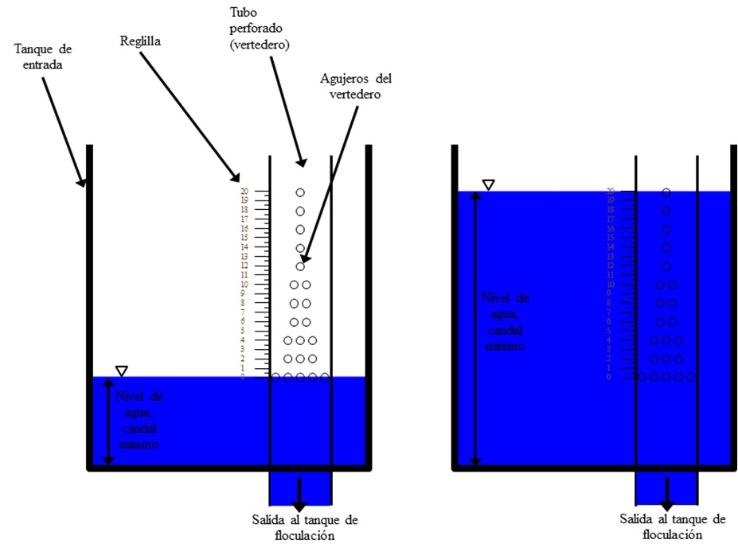

**Figure 1**: AguaClara Linear Flow Orifice Meter

The number of orifices in each row is calculated by minimizing the mean square error as compared to perfectly linearized flow. Table 2 gives the orifice pattern for this specific design.

|  |  |
| --- | --- |
| **Row Height (m)** | **Number of Orifices** |
| H.LfomOrifice1 | N.LfomOrifices1 |
| H.LfomOrifice2 | N.LfomOrifices2 |
| H.LfomOrifice3 | N.LfomOrifices3 |
| H.LfomOrifice4 | N.LfomOrifices4 |
| H.LfomOrifice5 | N.LfomOrifices5 |
| H.LfomOrifice6 | N.LfomOrifices6 |
| H.LfomOrifice7 | N.LfomOrifices7 |
| H.LfomOrifice8 | N.LfomOrifices8 |
| H.LfomOrifice9 | N.LfomOrifices9 |
| H.LfomOrifice10  Table 2.The orifice pattern in the LFOM for UI.City. The row height is measured from the bottom of the orifices in the first row. | N.LfomOrifices10 |

## Chemical dose controller (CDC)

The coagulation and disinfection processes require precise dosage of coagulant solution to the influent of the plant (raw water) and ​​solution of calcium hypochlorite to the plant effluent (filtered water). The CDC is hydraulically connected to the entrance tank, enabling the control system to automatically adjust the flow of chemical solution through the plant to maintain the desired dose even at varying flow rates. The coagulant serves to reduce the forces that keep colloidal particles in suspension and thus allow flocculation. The chlorine from calcium hypochlorite eliminates the remaining microorganisms after filtration that protects against contamination in the distribution network. To carry out this process without pumps, the AguaClara plant uses a hydraulic metering system called as the chemical dose controller. The main components of the system are storage drums, stock solution, an elevated platform to raise drums , chemical calibration columns, a float valve that maintains a constant liquid level, the dosing system that provides the required relationship between the pressure drop in the system and the flow of chemicals, and a scale in the inlet tank of the plant.

This system has the capacity of automatically shutting down when there is no flow in the plant and change the flow of chemicals automatically in proportion to the level of water in the inlet tank , which is linearly proportional to the flow rate of the plant due to LFOM. The first provides security against excess chemical pollution and wastage of chemicals in the event of plant shutdown without the need of manually stopping the chemical flow. The second allows an operator to select the dose easily without doing any calculations, and without manipulating the system each time the flow in the plant is changed.

Chemicals are stored in containers placed in an elevated table, from which the coagulant and chlorine flows to the two constant head tanks equipped with float valves. The float valves maintain constant liquid level in the tanks, which provides a constant level which is used to control the flow of each chemical hydraulically. In this way the flow of chemical is independent of the fluid level in the storage containers. The chemical solution leaving the tank respectively flows through a flexible tube of larger diameter, where there is no significant head loss , then to a " manifold" that divides the flow between several straight tubing with a smaller diameter (Figure 2) . The system of small diameter tubing serves as the main element of head loss in the flow path, so that major losses are more critical and minor losses (expansions) are kept minimal. The system is designed so because major losses in a laminar flow regime provide a linear relationship between flow and hydraulic head while the minor losses have a non linear relationship with the flow. A collector at the other end of the small diameter tube combines flow again and a large diameter tube leads to the metering device mounted on the tank wall of the plant.

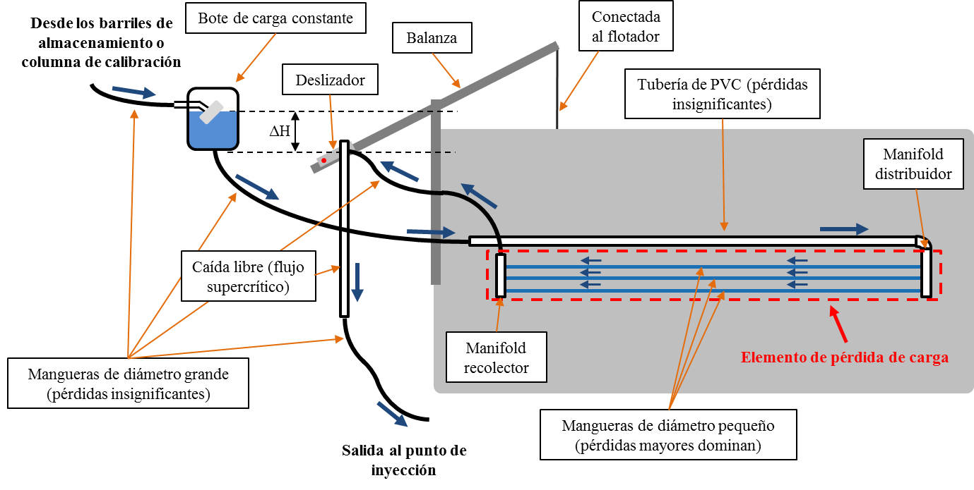

*The blue arrows indicate the path of the constant head chemical tank, small diameter pipes, and ending on the slider on the scale. The height of the outlet of the tube in the slider is what controls the chemical flow. Hence, the chemical falls in the PVC pipe and is injected into the raw water.*

**Figure 2**: AguaClara Chemical Dose Controller

The metering device consists of a lever system mounted on the tank wall and a large diameter drop tube (to ensure supercritical flow) that leads the solution to the raw water. As pictured in Figure 3, a ND.EtFloat diameter float hangs from the dosing lever arm and sits in the entrance tank. The left side of the lever arm is marked with a dosing scale and has a drop tube attached to a slider. The operator moves the slider along the left side of the arm to set the desired dose. The plant geometry is such that a double lever arm connects the entrance tank float to the chlorine and coagulant stock tanks, thus enabling the operator to control dosing of both chemicals from a single location. At the other end of the scale a float is attached to the inlet tank. When there is no flow through the plant, as shown in Figure 3, the dosing arm is level, and there is no head to drive the flow of chemical. When water is flowing through the plant, as shown in Figure 4, the float rises along with the water level in the tank, dropping the dosing point below the elevation of the fluid level in the constant head tank, and thus providing a driving head for chemical flow.

### 

*In no flow mode, the fluid level elevation in the constant head tanks is same as that of the dosing point, meaning there will be no flow of chemical into the plant. Note that the small tubes are not shown in the diagram for clarity*

**Figure 3**: Chemical Dose Controller at zero plant flow rate or in “no flow” configuration

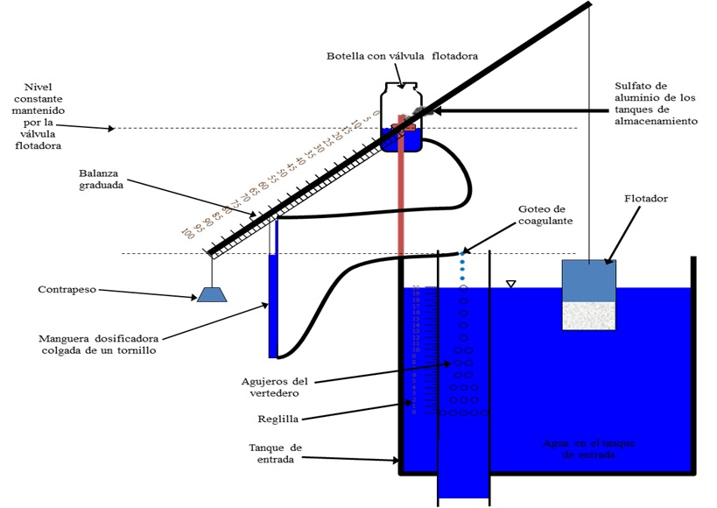

*The driving head for the chemical stock solution is given by the elevation difference between the fluid level in the constant head tank and the dosing point. Note that the slider is at the maximum dose point. Note that the small tubes are not shown in the diagram for clarity*

**Figure 4**:Chemical Dose Controller in the “Operating” mode

### CDC: Design Specifications

Table 5 lists the complete specifications for the dose controllers.

|  |  |  |
| --- | --- | --- |
| **Chemical Dose Controller Specifications** | | |
| ***General parameters*** | | |
| Coagulant Type | EN.Coag | |
| ***Chemical Concentrations*** | | |
|  | *Coagulant* | *Chlorine* |
| Maximum Dose | C.CoagDoseMax | C.ChlorineDoseMax |
| Maximum Stock Concentration | C.CoagStock | C.ChlorineStockMax |
| ***Tanks and Floats*** | | |
| ET Float diameter | ND.EtFloat | |
| ET Float height | L.EtFloat | |
|  | *Coagulant* | *Chlorine* |
| Float valve orifice diameter | D.CoagFloatValveOrifice | D.ChlorFloatValveOrifice |
| Stock tank to constant head tank tube diameter | D.CoagTubeStockToCH | D.ChlorTubeStockToCH |
| Large tube diameter (see CDC Design Alg.) | ??????????? | ??????????? |
| Flow Rate from Stock | Q.CoagStock | Q.ChlorineStock |
| ***Lever Arm and Drop Tube*** | | |
| Lever arm length (total) | L.LeverArmTotal | |
| Float Arm Length | L.CdcFloatArm | |
| Scale Arm Length | L.CdcScaleArm | |
| Drop Tube Length | L.DropTube | |
| Drop Tube Diameter | ND.DropTube | |
| ***Dosing Tubes for Flow Control*** | | |
| Minor loss coefficient | K.CdcTube | |
|  | *Coagulant* | *Chlorine* |
| Number of Tubes | N.CdcCoagTubes | N.CdcChlorineTubes |
| Length of Tubes | L.CdcCoagTube | L.CdcChlorineTube |
| Diameter of Tubes | D. CdcCoag | D.CdcChlorine |
| Maximum head loss through small-diameter tubing | HL.CdcCoag | HL.CdcChlorine |

Table 5.Chemical dose controller design for UI.City.

### CDC: Calibration and Operation

When there is no flow through the plant, as shown in Figure 3, the dosing arm is level, and there is no head to drive the flow of chemical. When water is flowing through the plant, the float rises along with the water level in the tank, dropping the dosing point below the elevation of the fluid level in the constant head tank, and thus providing a driving head for chemical flow. This situation is pictured in Figure 4. To decrease the chemical dose, the operator needs to move the slider to the desired dose marked on the scale of the level arm. With the slider moved further to the right, the dosing point elevation does not decrease as much as the float rises, and so the driving head – and thus the chemical flow – decreases.

Recall that the water height in the entrance tank changes linearly with the flow rate going through the plant due to the LFOM. Similarly, the flow of chemical stock solution is linearly related to the elevation difference between the fluid level in the constant head tanks and the dosing point. The linear relationship between the driving head of the chemical and the chemical flow rate is established by designing the dosing tubes such that the head loss is dominated by major(shear) losses. The lengths of the dosing tubes are limited by the need to have the tubes drape without hitting the floor.

For the doser to function optimally, it is crucial for each component to be installed correctly. To properly calibrate the doser once it has been mounted to the entrance tank, the no flow situation needs to be simulated in the entrance tank (Figure 3) by draining the tank until its water level is just below the bottom of the LFOM’s bottommost row of orifices. Then, with the lever arm perfectly horizontal, adjust the length of the rope attached to the float so that the float sits exactly vertically. With the lever arm in the horizontal position, mount the constant head tank such that its fluid level is at the same elevation as the dosing point. Then, fill the entrance tank until the water height corresponds to the maximum flow rate (where the topmost orifices of the LFOM are just submerged, as in Figure 4). The elevation of the maximum dose point on the scale should have decreased by the maximum allowable head loss for the chemical. Position the slider to an intermediate dose, because this method leaves extreme flow rates less susceptible to calibration errors.)At the intermediate dosing position, measure the flow of chemical through the dosing tube and compare it to the theoretical flow rate, which can be calculated by rearranging Eq 2 as follows:

Eq 7.

where hf is given by the elevation difference between the dosing point and the fluid level in the constant head tank. If the flow rate is greater than the theoretical, cut the tube and repeat the test until the theoretical value matches the measured value. If the flow rate is less than the theoretical, a longer tube must be obtained and the calibration must begin again from the first step. Once the theoretical and measured values match, the doser is ready for use.

In addition to good calibration, the doser must be periodically cleaned for good performance. Any sediment that may be clogging the valves or fittings must be cleaned out to prevent underdosing. Additionally, air bubbles in the tubes will cause dosing errors. If bubbles are present, remove the tube from the dosing system and force the bubbles out.

### CDC: Design Algorithm

The following sections give an outline of the methods used to design the CDC, which might be useful when troubleshooting the apparatus.

Recall that the water height in the entrance tank changes linearly with the flow rate going through the plant due to the LFOM. Similarly, the flow of chemical stock solution is linearly related to the elevation difference between the fluid level in the constant head tanks and the dosing point. The linear relationship between the driving head of the chemical and the chemical flow rate is established by designing the dosing tubes such that the head loss is dominated by major(shear) losses. The lengths of the dosing tubes are limited by the need to have the tubes drape without hitting the floor. The tubes must hang freely and have space for a weight to keep the tube as straight as possible, minimizing additional losses that would cause errors in the flow calculation. Moreover, the tubes cannot be too short, or else the number of tubes required to supply the needed flow gets high, and the apparatus gets complicated. To determine the best combination of lengths and numbers of tubes, we need to first determine the possible flow rates available from purchasable tubing diameters. Allowing no more than a ΠLinearCdcError = 10% deviation from the desired linear flow relationship due to minor losses, the flow rate, QAvailable, through each available tube size is calculated as given in Eq 1below.

Eq 1.

The diameter of the tube is D, the maximum headloss through the dosing system is HLCdc, g is the gravitation constant, and KCdcTube = K.CdcTube is the minor loss coefficient for the tube.

Modifying the Hagen-Poiseuille equation for the length of a tube, given major head loss hf, tube diameter, fluid viscosity ν, and fluid flow rate (Eq 2), the required length LCdcTubeof each tube to obtain the desired head lossat maximum flow may then be calculated for each available flow rate (Eq 4).

Eq 2.

Eq 3.

Eq 4.

When the length of the tube is being calculated, the true viscosity of the fluid is unknown, and so the viscosity of the maximum stock solution is assumed for the case of the coagulant. The viscosity of chlorine is assumed to be that of water since the solution must be sufficiently dilute to produce simple designs.

Once all possible lengths for each diameter have been calculated, the algorithm chooses the longest tube and associated diameter that is smaller than the maximum length to ensure draping. This decision minimizes the number of tubes, keeping the doser as simple as possible. At this point, the number of dosing tubes NCdcTubesassuming the maximum chemical stock concentration CChemStockMax can be calculated as follows in Eq 5:

Eq 5.

whereQPlant is the maximum plant flow rate, CMaxDose is the maximum allowable dose, and QTube is the flow rate through the design tube.

Finally, the required chemical stock concentration can be specified based on the calculation in Eq 6.

Eq 6.

In the event that the required tube length is not long enough to reach from the constant head tank to the drop tube, the small-diameter design tube may be linked to a larger diameter tube just long enough to reach the dosing point.

## Chemical storage tanks

There are two to four storage tanks for each chemical on the stock tank platform – two for the main plant coagulant, two for chlorine disinfection, and optionally two for coagulant dosing before filtration. The design of the chemical storage tanks is based on the tank volumes available for locally, and it is assumed that the stock tank will be refilled no more frequently than once every Ti.CoagStock for coagulant and Ti.ChlorineStock for Chlorine. In order to determine the required volume of a chemical tank, the maximum chemical flow rate, QChemStockMax, must first be determined as follows:

Eq8

Where CChemDoseMax is the maximum allowable chemical dose, and CChemStockis the stock concentration in the chemical tank. Using the maximum chemical flow rate,the volume of the stock tank, VolChemTank,is computed using the following formula:

Eq9

For plants that require stock tank volumes slightly larger than the nearest available tank volume, the ADT automatically rounds down to the nearest desired volume to make the size as small as possible. Specifications for this particular stock tank design are given in Table 6 below.

The vertical position of the coagulant tank must be high enough to provide enough hydraulic head to achieve the desired maximum chemical flow rate through the float valve orifice entering the constant head tank. This distance is given by H.CoagTankAboveHeadTank, and is added to the elevation of the water level in the constant head tank to find the elevation of the stock tank outlet.

All of the piping required to administer the dose and drain the stock tanks (Figure 5) uses a nominal diameter of ND.CoagPiping. The piping that connects to the constant head tanks begin at a bulkhead fitting set at an elevation of B.StockOutlet higher than the bottom of the stock tanks to prevent sediment from entering the pipes.



**Figure 5**: Chemical Stock Tanks

|  |  |  |
| --- | --- | --- |
| **Chemical Stock Tank Specifications** | | |
|  | *Coagulant* | *Chlorine* |
| Turnover time for the stock | Ti.CoagStock | Ti.ChlorineStock |
| Height of the chemical tanks above the constant head tanks | H.CoagTankAboveHeadTank | H.CoagTankAboveHeadTank |
| Dose and drain plumbing size | ND.CoagPiping | ND.ChlorinePiping |
| Coagulant tank volume | Vol.CoagTank | Vol.ChlorineTank |
| Height of stock tanks above constant head tanks | H.CoagTankAboveHeadTank | H.CoagTankAboveHeadTank |

Table 6.Chemical storage tank design for UI.City.

All of the piping required to administer the dose and drain the stock tanks uses a nominal diameter of ND.CoagPiping. The piping that connects to the constant head tanks begin at a bulkhead fitting set at an elevation of B.StockOutlet higher than the bottom of the stock tanks to prevent sediment from entering the pipes. The flow is controlled at the top of the stock tank platform using a ball valve, and the plumbing continues down through the platform, and out through the wall facing the entrance tank at the approximate elevation of the constant head tanks. The stock tank drains are connected from the bottom center of the tanks, starting with a male insert, and continuing under the platform and exiting via ball valve at the edge of the main plant drain channel. Figure 8 shows more close up details of the dosing and chemical drain plumbing.

## Rapid Mix

Once it has been dosed with coagulant, the water passes through the rapid mix system. Rapid mix serves to uniformly distribute the coagulant through the raw water. In this plant, the rapid mix occurs as turbulent flow through a pipe with an inner diameter of ND.RMPipe. This pipe brings water from the point at which coagulant is dosed to the filters.

## Low Flow Stacked Rapid Sand Filtration: LFSRSF

The AguaClara Low Flow Stacked Rapid Sand Filter (LFSRSF) is a municipal-scale filter designed for communities of about 500 people. The filter is a non-conventional filtration system designed to occupy minimum area, operate without electricity, use minimum number of mechanical parts, be easy to operate and maintain while achieving high level performance in particle removal along with the efficient use of water for backwashing. The process is simply to pass the settled water through a bed of sand where the suspended particles/ microorganisms are captured. It is necessary to backwash the filter at least once each day to remove accumulated sediment in the sand. Adapted from the AguaClara Stacked Rapid Sand Filters (SRSFs), these filters are designed to treat a flow rate of 0.8 L/s. The filter operates in two modes: forward filtration, in which water flows in parallel through six vertically stacked sand beds, and back-wash, in which all of the filter’s flow is diverted to the bottom inlet, fluidizing the sand bed and carrying all of the dirt accumulated during filtration up and out of the filter through the backwash-to-waste pipe.

The technology is a culmination of two key innovations. The first is the manner in which the sand bed is backwashed where the bed is fluidized without using a pump. The backwash cycle requires a water velocity of about six times higher than the filtration cycle to fluidize the sand and remove the accumulated particles. The AguaClara LFSRSF, unlike many conventional filtration systems, is powered entirely by gravity and has multiple sand layers stacked vertically instead of having the units in parallel arrangement thus making the filter more compact. Entire flow is divided between the inlets of the six layers in the filtration cycle and concentrated on one bottom inlet in the backwash cycle. The second key AguaClara innovation is the use of a siphon system for controlling the two operating modes of filtration to avoid the use of complex pumping systems or valves. The pressure drop in the filtration cycle is a small fraction of the pressure drop incurred during backwash cycle in which the entire flow is directed (six times the velocity during operation mode) at the bottom to fluidize the sand. However, the water enters the system in the two modes at the same height in the entrance tank. Therefore, to switch between the two modes the height at which the water leaves the system has to be changed. Backwash is initiated in the LFSRSF with a single valve on the backwash pipe. When the valve is opened, the water is directed out of the backwash pipe into the drainage channel of the plant at a much lower height. To operate the entire system, the operator has to manipulate a single valve and the process continues automatically.

***Operation***

Filtration begins once raw the water is dosed with the coagulant and is mixed in the rapid mix pipe. To ensure the filter functions optimally, the water must be sufficiently treated at the start of the process to a low turbidity. Raw water dosed with coagulant from the rapid mix flows into the entrance tank of the filter. During the filtration cycle the four pipes in the entrance tank direct water to the filter and it is distributed to 6 layers of sand through slotted pipes in the sand bed (via the branches of the manifold). The water flows either up or down through each sand bed where the particulates get trapped in the voids of the sand bed. Filtered water exits the system through the three exit pipes leading to the exit tank.   
In the backwash cycle all the water passes through the lowermost inlet tube and out the siphon that collects water from above the filter bed. The dirty backwash water discharges into the drainage channel of the plant.

  
 *Hydraulic Controls: One valve on the backwash exit pipe is all that is required to switch between the operating and backwash modes. Note the differing water levels in the entrance and exit tanks, and the water path during each mode.*

**Figure 6**: Low Flow Stacked Rapid Filter in Operation and Backwash Mode

***LFSRSF Design Algorithm***

### 

### LFSRSF: Design Specifications

|  |  |
| --- | --- |
| **LFSRSF Design Specifications** | |
| ***General parameters*** | |
| Number of filters | N.Fi |
| Maximum flow rate of each filter | Q.Fi |
| Diameter of the main Filter Column | ??? |
| Total depth of sand in the filter | H.FiSand |
| Number of layers in each filter | N.FiLayer |
| Depth of sand in the top 5 layers | H.FiLayer |
| Depth of sand in the bottom layer | H.FiBottomLayer |
| d60 | D.FiSand60 |
| Porosity of the sand | Porosity.Sand |
| Center to center distance between branches | B.FiManifoldBranch |
| Number of branches in each layer | N.FiManBranch |
| Slotted Tube Specification | Schedule 40 |
| ***Pipe Diameter*** | |
| Trunks (except the backwash line) | ND.FiTrunk |
| Backwash line (bottom entry) | ND.FiBwTrunk |
| Inlet and Outlet Branches (except backwash) | ND.FiManBranch |
| Backwash Branches (bottom entry) | ND.FiBwManBranch |
| Backwash Line | 6” |
| Valve on the Backwash Line | 0.5" |
| Sand Drain | ND.FiSandOutlet |
| Tube that receives input and output branches (except backwash) | 2” |
| Tube receiving branches backwash | 2” |
| ***Normal Inlet and Outlet Branches (5 manifolds in the middle)*** | |
| Slot width | W.FiManSlots |
| Slot length (measured in the curve of the inner diameter) | 1.45” (3.68 cm) |
| Center to center spacing of the slots | B.FiManSlot |
| Number of rows of slots | N.FiSlotRows |
| Total number of slots on each branch | N.FiManSlotsPerBranch |
| Total length of each slotted tube | 21.0” (53.3 cm) |
| ***Backwash Branches*** | |
| Slot width | W.FiManSlots |
| Slot length (measured in the curve of the inner diameter) | 1.22” (3.11 cm) |
| Center to center spacing of the slots | B.FiBwManSlot |
| Number of rows of slots | N.FiBwSlotRows |
| Total number of slots on each branch | N.FiBwManSlotsPerBranch |
| Total length of each slotted tube | 18.9” (48.0 cm) |
| ***Top Layer Branches*** | |
| Slot width | W.FiManSlots |
| Slot length (measured in the curve of the inner diameter) | 1.09” (2.76 cm) |
| Center to center spacing of the slots | 3/16” (4.76 mm) |
| Number of rows of slots | N.FiBwSlotRows |
| Total number of slots on each trunk | ??? |
| Total length of each slotted tube | 21.0” (53.3 cm) |
| ***Key Elevations (measured from the bottom of the sedimentation tank) ??????*** | |
| Filter Bottom Elevation | Z.FiBottom |
| Filter Top Elevation | Z.FiTop |
| Backwash siphon exit | -0.67 m |
| Outlet pipes exit | 1.02 m |
| Entrance tank bottom | Z.FiEntranceBottom |
| Exit tank bottom | Z.FiExitBottom |

# Materials List

Estaseccion describe parametrosutiles y estimaciones de los materials necesariospara la construccion de estaplanta. Las dimensiones y materials descritasaquiestandivididasacorde a la unidadoperacional de la planta a la quepertenecen.

### Entrance Tank

* El volumen de concretonecesarioparaconstruir el tanque de entradaesVol.EntranceTank.
* El suelodeltanque de entradatiene un area de A.EtFloor.

### Linear Flow Orifice Meter

* sgsf

Manguera que trae el sulfato de aluminio de los tanques de almacenamiento de coagulante

Manguera dosificadora colgada de un tornillo

Contrapeso

Botella con válvulaflotadora

Balanza graduada

Tanque de entrada

Flotador

Reglilla

Agujeros del vertedero

Goteo de coagulante

(apagado)

Nivel constante

Agua en el tanque de entrada

### Chemical Dosing System

* Sdfh

### Chemical Storage Tanks

* Sgsf

### Overall Plant

* Plumbing
* Concrete

Manguera que trae el sulfato de aluminio de los tanques de almacenamiento de coagulante

Manguera dosificadora colgada de un tornillo

Contrapeso

Botella con válvulaflotadora

Balanza graduada

Tanque de entrada

Flotador

Reglilla

Agujeros del vertedero

Goteo de coagulante

(apagado)

Nivel constante

Agua en el tanque de entrada